Game Design Document

Project Kobra

Kobra Logo

#### Created by Callam Bennett

#### Student name

|  |
| --- |
| Callam Bennett |

#### Student Card number

|  |
| --- |
| 10554518 |

#### Game Name

|  |
| --- |
| KOBRA |

#### Trello link

|  |
| --- |
| https://trello.com/b/lu5grspS/aint152-games-workshop |

#### GIT repository link

|  |
| --- |
| https://github.com/CallamBennett412/AINT152---Project-Kobra |

#### Youtube playthrough link

|  |
| --- |
|  |

# Game Story

#### Game backstory

|  |
| --- |
| Chief Petty Officer Archibald Kobra, leader of the elite Kobra task force, has been sent to the Hyperion System on Asca V to dispatch and destroy a rogue insurgent droid base. His objective… to destroy all hostiles, overload the reactor and escape Asca V before the droid base has been destroyed.  However like most black op campaigns there are always complications… as Kobra succeeds in his mission to overload the reactor the base goes dark, all power lost, this means he cannot overload the reactor.... Kobra’s new objective is to discover why the power went out but in the darkness something more deadly than rogue droids lurk… It seems as if the base was housing something more… deadly... |

#### 

## Character 1

#### Character name

|  |
| --- |
| Archibald Kobra |

#### Appearance

|  |
| --- |
| * Orange Armored Neo Mech suit * Orange/blue colour scheme * Colour used to help the player see and visualise where the player is * Handles a modified Korbra MX.III Laser Rifle as default weapon |

#### Character backstory

|  |
| --- |
| Most of Kobra’s backstory is marked out with black ink, no one truly knows this man, but the members of the Alliance knows him as a hero. What people do know of this mysterious soldier is that he started out as a special forces space cadet in the Alliance Terra Command building himself up as marine. A few years before Operation Mech a man with the name of Kobra led a small group of cadets destroying all of Asca IV’s insurgent’s leaders and imploading the planet itself. Asca IV is no longer habitable. It is rumoured that Kobra died out on Asca IV in the Terra civil war.  Regardless of the rumours a soldier with the name of Kobra went on to lead a team through more black op missions throughout the coming years, his kill count becoming the highest in Alliance history, but with each operation a member of his team fell until he was the only one left. Kobra has little emotion, acting more like a cyborg than a human. His cold nature occured after he and his team glassed the planet Perros killing over a billion of people on the mining system; both innocent and not. |

#### Stereotypes

|  |
| --- |
| * Armour and weapons based on Metroid * Personality and character is heavily based upon Master Chief from the Halo series so he is the silent but deadly protagonist stereotype that everyone respects, however my character shows more of an darker evil streak where he will do anything to complete the mission, even if it means casualties. * Doesn’t talk but is badass * Typical super soldier that can beat an army single handed * Extremely intelligent and is specialized in all aspects of field work (explosives, weapons, vehicles, and flying) |

## 

## 

## Character 2

#### Character name

|  |
| --- |
| Insurgent Rogue Droid |

#### Appearance

|  |
| --- |
|  |

#### Character backstory

|  |
| --- |
| Mechanical brainless machines programmed and created on the Asca V colony by an unknown company before it’s abandonment. Members of the Xhan Insurgency came to Asca V and started creating the droids to bolster their army.  However while the droids are now under the control and being built by Xhan, all of the insurgents are never seen when Kobra arrives…  The Droids are based upon an ancient alien design called the Becta’s and they are the forefront of mechanical warfare but the droids were ordered to shut down after the Terra Civil war ended. They have not seen operation until Xhan. |

#### Stereotypes

|  |
| --- |
| They fit the stereotype of dumb easy to kill enemies in games however when they swarm they become a problem. On their own they are weak and easy to kill but in large numbers they can easily kill the player.  Based on the droids from Star Wars, dumb silly machines, and they fire a red energy laser rifle like most enemies in games, red symbolises danger. |

## 

## 

## Character 3

#### Character name

|  |
| --- |
| Insurrectionist Leader Aka. Gordon Kobra |

#### Appearance

|  |
| --- |
| * Orange Armored mech suit outdated model compared to Archibald Kobra’s Neo Suit. * Orange/blue colour scheme * Custom addons on the suit using whatever he can get his hands on. |

#### Character backstory

|  |
| --- |
| Kobra was a title given to the most elite of soldier’s in the Alliance Terra Army, however the first person to hold the title was known as Gordon Kobra. He led a small group of soldiers in an attack against insurrectionists on Asca IV resulting in the death of their leaders. He then became renowned as the first Kobra. Kobra sought the betterment of humanity but when he was ordered to implode Asca IV he refused and instead aided those rebels he once fought against. However the Alliance found a way to implode the planet itself killing all those who still remained. It is thought that the first Kobra perished on that rock.  Gordon found a way off Asca before the planet killing event with a small group of rebels, becoming the new leaders of the Xhan Insurgency, a few years after Gordon came across Asca V, deciding to use the droid facility to bait out the man who tarnishes his name. |

#### Stereotypes

|  |
| --- |
| Gordon is not your stereotypical antagonist, due to the fact that he is actually the morally good guy. He has very strong values and like most stereotypical hero esque characters he wishes peace and to save all those worth saving. He, like a typical insurrectionist who hates corrupt governments, has a strong hatred for the Alliance seeing them as an evil corporation after killing billions of innocents and using his name to do it. |

## Character 4

#### Character name

|  |
| --- |
| Terra Mark.X CPMS (Combat purpose Mechanical suit) Nicknamed: Mantis |

#### Appearance

|  |
| --- |
|  |

#### Character backstory

|  |
| --- |
| Built during the Terra Civil war as a means to kill and dispatch enemies with ease. While it is slow and clunky to move it boasts massive fire power shooting lasers at rapid speed. Mantis was pivotal to large Operations and soon became Kobra’s favorite means of transport. Not only can the Mantis be manned by soldiers it also contains an AI allowing the mech to fire at targeted enemies. However Xhan have found a way to utilize the AI turning the Mantis to their side.  The Mantis can prove problematic for those having to face it... |

#### Stereotypes

|  |
| --- |
| * Mech Suit based on the suit from the film District 9 * Heavy ordnance for the player to use when needed * Extremely tough armour * Loads of fire power * Weak to fast movement * Weak to being shot in the cockpit and behind |

# 

# Visual style

Using other game images, describe the visual style of your game

|  |
| --- |
| <Floor tiles  My Game art Style^^ - 16/32 bit pixel art and game environment. Wanted to mix the two in order to make the game have simple art work but also be able to make certain things more detailed. For example I had the idea to make the Environment and levels 32 bit so I can add various different objects and details to the game.  Inspired game designs: |

# 

# Sound design

Details about the style of sound used in your game (music style, thematic treatment, FX, menu music)

|  |
| --- |
| Kobra will have a old school catchy and cheesy typical sci-fi shooter style music similar to that of space invaders or galaga. The FX will be that of laser sounds, energy rumbling and ambient sci-fi sounds (such as electricity tesla’s, machines, reactors and batteries).  However Kobra will suddenly take a dark turn when all the lights go off and the theme of the game changes quite rapidly. Suddenly the music goes from being a classic upbeat sci-fi theme to a dark gritty horror. The music has sci-fi elements such as beeping and alarms but the rumbling of machines becomes more sinister and deeper. Some of this section will also have silent ambience in order to build up tension and scare. |

# Menu System

#### Menu flowchart

|  |
| --- |
|  |

## Menu Screens

#### Main menu diagram

|  |
| --- |
|  |

#### Main menu description

|  |
| --- |
| Simple menu design that shows four options on the screen. Continue will close the menu and take the player back to the game where they paused it. Load will allow the player to load the game from any save point that they have previously been too. This will prevent the player from having to restart the game over and over again. Options will open a completely separate overlay UI and it is meant to give the player visual and audio feedback on the game, the player will be able to change the gameplay to meet their requirements (if it is too easy or too hard) I plan on doing this via a slider instead of difficulty levels in order to give the player more freedom of custom choice. Audio again will use sliders in order to adjust sound volumes, for example if they wanted the music to be quiet they just have to slide the slider down to make the music silent. The same will go for effects, and ambience sounds.  Controls will open a visual overlay showing a keyboard/mobile/controller (depending on format) with all the control mappings for the user to see. The user will then be able to change the controls to fit their own personal standard, making it easier for them to play the game. Pressing back will take the player back to the menu screen incase they need to do anything else via the menu, and when the player is done and satisfied they can either press continue OR select exit game, which as the name suggests will close the game. |

#### Game Over screen diagram

|  |
| --- |
|  |

#### Game Over description

|  |
| --- |
| When the player dies they will see the game screen fade to black with animated static bordering the game over screen. A sound cue will activate upon death also symbolising the game over. Upon the game over appearing the player will then gain access to 3 options in order to continue. If the player picks the “Load Game” option then they will load the to their last save point where they can continue on with the game. Or they can choose to start a new game if they wish to do something different with their gameplay. The last option will exit the game and close if the player is done with the game and does not wish to continue. |

#### Game screen diagram

|  |
| --- |
|  |

#### Game Screen description

|  |
| --- |
| For the game screen UI overlay I thought I would go down a traditional shooter style UI. With this in mind I opted to have the weapons and ammo section in the bottom left corner like you see in most shooter games such as Call of Duty and Battlefield. To the right of the weapons section I added in a special abilities area where the player can see what abilities they have and if they can use them. Above the Weapons section I thought it would be a good idea to implement a minimap however I also think that this is something that the game doesn not need, it is only here as an idea at the current stage.  On the right side of the screen in the top corner I will implement an object tracker, this will be a very brief description of what the player needs to do in order to progress in the game. This will allow the player to follow the game easily without getting stuck. At the top of the screen you will see your players health bar and ability bar, these will go down or up depending on what happens throughout the game, they will also flash if they become too low.  In the bottom right corner I came up with an idea that if I was to implement this game on mobile phones then the joystick to move the player would be placed here. This is because most mobile phone games play in a right handed format where the right thumb controls movement. I have opted to go along a similar path if I was to implement my game into the mobile phone market. |

# 

# Game Elements

## Player Character

#### 

|  |  |
| --- | --- |
| Character name | Graphics |
| Archibald Kobra |  |

#### 

|  |  |  |
| --- | --- | --- |
| Property | Description | Type |
| * Movement * Shooting Laser Rifle * Shooting Beam Rifle * Shooting Scattergun * Health bar * Ability Bar * Animations * Abilities (Push back, grenade, and shield) | Player will move around the map depending on which input is pressed.  Player will shoot using the fire button, the gun will depend on which gun the player is holding which the player will be able to swap out at any point.  Player will have a health bar so the player can be damaged by enemies, but also can heal himself.  Player has an ability bar that will allow him to use his abilities whilst having charge in the ability bar, this will deplete with each ability being used and then will slowly charge back to full.  Animations of the player will occur when the player is moving.  Abilities being used will show a visual cue and push back enemies, throw an explosive or cast a shield around the player, | Player |

|  |  |
| --- | --- |
| Sound name | Description (how does the sound interact with the game) |
| * Footsteps * Shooting * Reloading * Abilities | When Player moves it will create a heavy footed sound of a metallic mesh suit hitting a hard floor, this will tell the player that the character is moving.  When the player shoots his gun it will output a laser firing sound, rapid laser sounds for the Laser rifle, a long steady sound for the beam rifle, and a short shotgun sound for the scattergun, this will tell the player that they are shooting.  When the player reloads his gun it will output a short 3 second sound and when the sound is finished it will tell the player that the gun is ready to fire again.  When the player uses an ability a sound like a power up of energy will be outputted to tell the player that the ability has been cast. |

## Enemies

|  |  |
| --- | --- |
| Enemy name | Graphics |
| Rogue Insurrectionist Droid |  |

#### 

|  |  |  |
| --- | --- | --- |
| Property | Description | Type |
| * Movement * Shooting * Animations | Droids will move slowly towards the player whilst simultaneously shooting at the player, this will only occur when the player is within range of the droid. When the player is not within range of the player then the droid will move randomly or within a set patrol route.  The droids will shoot red laser bolts at the player from their laser rifle.  The droids will have movement animations for when they move. | Enemy |

|  |  |
| --- | --- |
| Sound name | Description (how does the sound interact with the game) |
| * Footsteps * Shooting * Death | The droids will have clanking metal footsteps which the player will hear if they are moving.  When the droids shoot they will give off a different sounding laser blast to the player so that the player does not get confused.  Death of the droids will result in a malfunctioning sound and a mini short circuit explosion. |

## Blocks

|  |  |
| --- | --- |
| Block name | Graphics |
| Floor tiles:  FT_Silver_Blue  FT_Silver_Green  FT_Silver_Purple  FT_Silver |  |

#### 

|  |  |  |
| --- | --- | --- |
| Property | Description | Type |
| * Sound * Animation * Collision * Light | Each coloured tile will emit a small humming sound as well as light to help set the environment of the levels.  The coloured pads will flash different colours depending on the room and environment.  With these being floor tiles the coloured tiles are actually lights as well which means the player will not be able to stand on them. | Floor_Tile |

|  |  |
| --- | --- |
| Sound name | Description (how does the sound interact with the game) |
| * Low Electronic humming | When approaching a light tile you will hear a very faint hum coming from the tile. This will be used to add ambience to the levels and help create a sci-fi environment. |

## Collectibles

|  |  |
| --- | --- |
| Collectible name | Graphics |
| Ammo crate  Weapon  Medkit | [To be implemented] |

#### 

|  |  |  |
| --- | --- | --- |
| Property | Description | Type |
| * Refilling ammo * New weapon * Increasing Health | Ammo crates will give the player more ammo for the player to shoot out of his gun. If the player runs out of ammo then the player will need to find these Ammo Crates in order to continue shooting.  New weapons will be dropped by enemies or found throughout the levels, each gun will do something different and add a new style of gameplay. They will be seen via a sprite on the floor. | Pickups |

|  |  |
| --- | --- |
| Sound name | Description (how does the sound interact with the game) |
| * Ammo crate unboxing * Weapon pickup * Health sound | If the player picks up a ammo crate the a sound cue of a crate being opened or the sound of bullets being jangled will be played.  When a weapon is picked up depending on the gun it will make a noise;   * Beam rifle will make a energy charging noise * Scattergun will make a shotgun pumping noise   When the player picks up a health pack it will make a noise similar to that of the half life med pack noise. When this noise is played the player’s health will increase by an increment of 40%. |

# Level plan

Sound design

|  |
| --- |
| First few levels of the game: Uplifting techno sci-fi music with sci-fi ambient noises such a lasers, electrical discharges, humming of reactors and other machinery sounds. All of these sounds will be made to sound adrenaline pumping and action packed.  After plot twist climax: The uplifting vibe dissipates and is replaced by a more creepier theme and soundtrack. The sounds are meant to instill fright into the player as the game changes theme into a more thriller style gameplay. The ambience of the game will also change making all the same sounds lower pitch but overlaying the sounds with extra effects to make them for the thriller theme. |

## Key

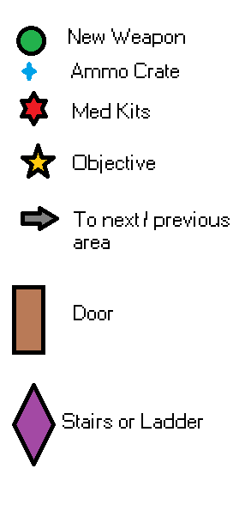

## Level Diagrams

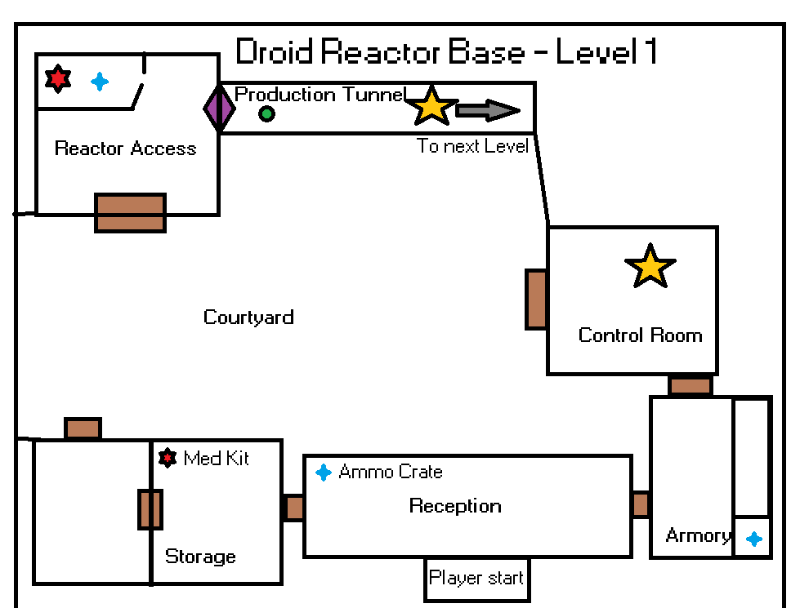

# Game Breakdown

#### Space

|  |
| --- |
| * Free roam of each level * Linear level design so the players knows where to go * Some levels will not have a linear design and more of a free roam aspect to it |

#### Rules

|  |
| --- |
| * Complete Objectives * Kill Droids * Don’t die * Save the game at save points |

#### Goal

|  |
| --- |
| * To complete each objective and goal of the game as they come * To infiltrate and destroy the reactor of the droid manufacturing base (until objective is changed) * Evade the alien and survive * Turn power to the facility back on * Find a way to kill the Alien |

#### Game Elements

|  |
| --- |
| * Shooting droids and small aliens * Using your weapons to slow, paralyze and evade the big alien * Ammo Kits to replenish reserves * Health kits to stop the player character from being killed * Dialogue * Objectives * Different Weapons * Voice acting and custom sounds * Custom music * Mech suit vehicle |

#### Mechanics

|  |
| --- |
| * Shooting a rapid firing laser rifle * Shooting a laser beam from the beam rifle * Laser’s that scatter from the scatter gun * Top down view * Top down movement style * Not tiled movement so can move unhindered in any direction * Object Collision * Sound effects * Health for player and enemies * Vehicles |

#### In game controls

|  |
| --- |
| W - Move up  A - Move Left  S - Move down  D - Move right  Left Click - Shoot gun  R - Reload  F - Swap Weapon  1 - Ability 1  2 - Ability 2  3 - Ability 3  Mouse cursor - Moves in that direction |

# Game Systems

Document any game systems included.

Examples:

* Level timer (do something before the timer runs out)
* Survival (Player survives sustained attack)
* Dialogue (other characters talk to the player in popup windows)
* Character selection
* Inventory system
* Player attributes (e.g. energy, mana, stamina, strength etc)

Dialogue

Dialogue will be implemented into the game in order to help the player progress but also to give the player more of a foundation for story and a connection to the player that they are playing as. The Dialogue in the game will appear in the bottom portion of the screen when a dialogue scene is activated.

Example of Dialogue in game:

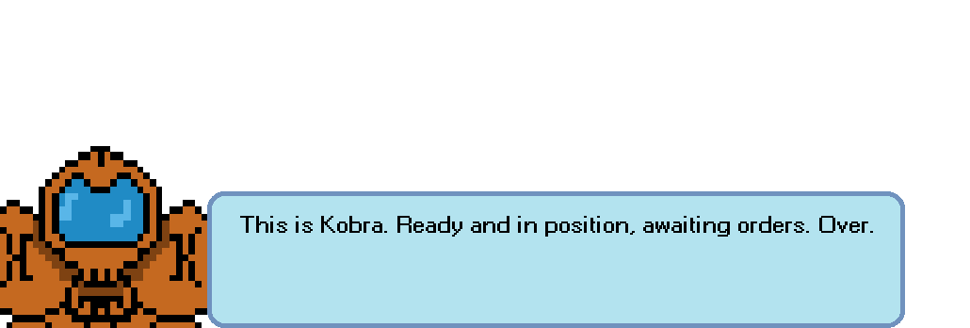

Player Attributes

The player will have a health bar that will lose health upon being shot, but can also be replenished via the use of Med Kits found scattered on the levels. If the player’s health reaches 0 then the player will die and the game will cut to the game over screen.

The second attribute will be the ability bar, this bar is otherwise known as the suits charge, and will allow the player to use abilities while the suit has charge. When the player does not use an ability the ability bar will slowly charge itself.

Vehicles

The game will also be featuring various different vehicles that the player can use in order to progress through the level. Vehicles do different things so each vehicle will help the player in different ways. For example the Mech Suit is a heavy ordnance tank which will dispatch and kill enemies quickly.

# Press Kit

#### Store icon/Logo

|  |
| --- |
|  |

#### Core features

|  |
| --- |
|  |

#### Screenshots

|  |
| --- |
|  |

#### Rating

|  |
| --- |
|  |

## Similar games

#### Game name

|  |
| --- |
| SAS Zombie Assault 4 |

#### Game link

|  |
| --- |
| https://ninjakiwi.com/Games/Action/SAS-Zombie-Assault-4.html |

#### Game name

|  |
| --- |
| Alien Swarm |

#### Game link

|  |
| --- |
| http://store.steampowered.com/app/630/Alien_Swarm/ |

#### Game name

|  |
| --- |
| Psychon 2 |

#### Game link

|  |
| --- |
| https://benjames171.itch.io/psychon-2 |

## Youtube review channels

#### Channel name

|  |
| --- |
|  |

#### Channel link

|  |
| --- |
|  |

#### Channel name

|  |
| --- |
|  |

#### Channel link

|  |
| --- |
|  |

#### Channel name

|  |
| --- |
|  |

#### Channel link

|  |
| --- |
|  |